 | CS606 Compiler Constructions  Assignment # 4
Instructions :
Your assignment must be uploaded/submitted before or on 20th June 2011.

- Your assignment must be in .doc format.(Any other formats like scan images, PDF, Zip, rar, bmp, docx etc will not be accepted)
- Save your assignment with your ID (e.g. bc020400600.doc).
- No assignment will be accepted through email.

It should be clear that your assignment will not get any credit if:

- The assignment is submitted after due date.
- The submitted assignment does not open or file is corrupted.
- Your assignment is copied from internet, handouts or from any other student (Strict disciplinary action will be taken in this case).

Constructing the LALR Parsing Table
LALR (LookAhead LR(1)) parsing table can be obtained by the following steps:
- Very first we will obtain LR(1) items.
- After this we will calculate canonical collection.
- Now we will combine those canonicals which have same LR(0) (Since LR(1) is made off LR(0) and lookaheads) but having different lookaheads.
- Now we will construct Action Table on reduced collection:
We will follow following steps:
- If (A → α., aβ, b) is in l_{i} and goto ( l_{i} , a) = lj set action [ l_{i} , a] to shift j(S_{j}).
- If (A → α., b) is in li and goto [l_{i} , b] = reduce A → α (R_{k}, where K is number of production A → α in non-augmented grammar).
- If [S’ → S., $] is in l_{i} then
Set action [l_{i} , $] = “Accept”
- Construction of goto Table: We can do it by following algorithm:
For every li in C do
For non-terminal A do
If goto (li, A) = l_{j} then
Set goto [l_{i}, A] = j

Question 1: [20]
Consider the following grammar:
S → AA
A → aA
A → b
And construct the LALR parsing table by understanding the above method.

Solution:

The augmented grammar is
S’ → S
A → AA
A → aA
A → b

Now we will find the canonical collection of sets of LR(1) items:
l₀ = closure (S’ → .S, $) = {S’ → .S, $
S → .AA, $
A → .aA, a/b
A → .b, a/b
}
l₁ = goto (l₀, S) = closure (S’ → S., $) = {S’ → S., $}
l₂ = goto (l₀, A) = closure (S → A.A, $) = {S → A.A, $
A → .aA, $
A → .b, $
}
l₃ goto (l₀, a) = closure (A → a.A, a/b)
{A → a.A, a/b
A → .aA, a/b
A → .b, a/b
}
l₄ = goto (l₀, b) = closure (A → b., a/b) = {A → b., a/b}
l₅ = goto (l₂, A) = closure (S → AA., $) = {S → AA., $}
l₆ = goto (l₂, a) = closure (A → a.A, $) = {A→ a.A, $.
A → .aA, $
A → .b, $
}
l₇ = goto (l₂, b) = closure (A → b., $) = {A → b., $}
l₈ = goto (l₃, A) = closure (A → aA., a/b) = {A → aA., a/b}
l₉ = goto (l₆, A) = closure (A → aA., $) = {A → aA., $}
Rest of goto (li, X) (Where X is grammar symbol) are same as l₀, l₁, l₂, l₃, …, l₉ So
C = {l₀, l₁, l₂, l₃, l₄, l₅, l₆, l₇, l₈, l₉}
If we carefully analyze then LR(0) items of l₃ and l₆ are same but they differ only in their lookaheads.
l₃ = { → a.A, a/b
A → .aA, a/b
A → .b, a/b}
l₆ = { → a.A, $
A → .aA, $
A → .b, $}
Clearly l₃ and l₆ are same in their LR(0) items but differ in their lookaheads, so we can combine them and called as l₃₆.

l₃₆ = { → a.A, a/b/$
A → .aA, a/b/$
A → .b, a/b/$}
So now C becomes as follows:
C = {l₀, l₁, l₂, l₃₆, l₄₇, l₅, l₈₉}
Where
l₀ = {S’ → .S, $
S → .AA, $
A → .aA, a/b
A → .b, a/b
}
l₁ = {S’ → S., $}
l₂ = {S → A.A, $
A → .aA, $
A → .b, $
}
l₃₆ = { → a.A, a/b/$
A → .aA, a/b/$
A → .b, a/b/$}
l₄₇ = {A → b., a/b/$$}
l₅ = {S → AA., $}
l₈₉ = {A → aA., a/b/$}
Let us design the FA as follows:

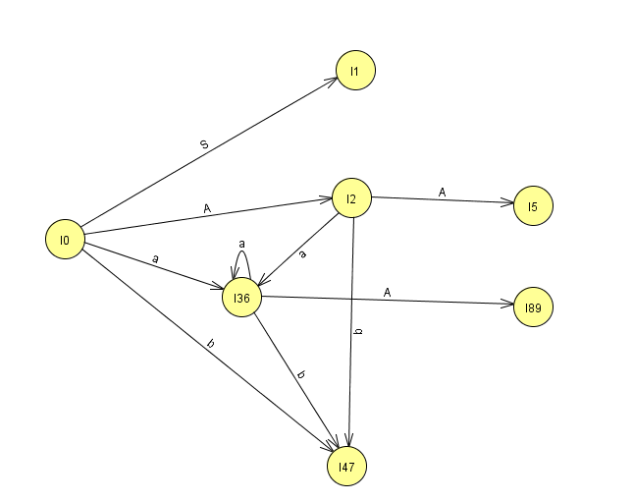

LALR parsing table is as follows:

 | Action table |  |  | Goto table
 | a | b | $ | S | A
l₀ | S₃₆ | S₄₇ |  | 1 | 2
l₁ |  |  | Accept
l₂ | S₃₆ | S₄₇ |  |  | 5
l₃₆ | S₃₆ | S₄₇ |  |  | 89
l₄₇ | R₃ | R₃
l₅ |  |  | R₁
l₈₉ | R₂ | R₂ | R₂

Note:
- Your answer must follow the below given specifications. Marks will be deducted if you do not follow these instructions.
- Font style: “Times New Roman”
- Font color: “Black”
- Font size: “12”
- Bold for heading only.
- Font in Italic is not allowed at all.
  - You should consult recommended books to clarify your concepts.
  - It’s better for you to submit the assignment well before the deadline.
  - Do not put any query at MDB about this assignment, if you have any query then email at CS606@vu.edu.pk

